Visvesvaraya Technological University
Belagavi-590 018, Karnataka

A Project Report on
“PATH FINDER”

Project Report submitted in partial fulfillment of the requirement for the Award of degree of
Bachelor of Engineering in
Information Science and Engineering

Submitted by
ARJUN HN [1JT13IS006]
KARTHIK KUMAR H [1JT13IS012]
VARUN K MURTHY [1JT13IS028]

Under the Guidance of
Mr. Kishore G R
Assistant Professor, Dept. of ISE



Department of Information Science and Engineering
Jyothy Institute of Technology
Tataguni, Bengaluru-560082

Jyothy Institute of Technology

Tataguni, Bengaluru-560082

Department of Information Science and Engineering

CERTIFICATE

Certified that the project work entitled “PATH FINDER” carried out by Mr. ARJUN H N [1JT13IS006], a bonafide student of Jyothy Institute of Technology, in partial fulfillment for the award of Bachelor of Engineering in Information Science and Engineering department of Visvesvaraya Technological University, Belagavi during the year 2016-2017. It is certified that all corrections/ suggestions indicated for Internal Assesment have been incorporated in the Report deposited in the departmental library. The project has been approved as it satisfies the academic requirements in respect of Project work prescribed for the said Degree.

Kishore G.R Dr. Harshavardhan Tiwary Dr. Mahendra K.V
Asst. Professor Head of Department Principal
Guide

- External Viva

- Examiner

Signature with date

DECLARATION

We, the students of final semester of Information Science and Engineering, Jyothy Institute of Technology, Tataguni-560082 declare that the work entitled “PATH FINDER” has been successfully completed under the guidance of Mr. Kishore G R, Asst. prof., Information Science and Engineering Department, Jyothy Institute of Technology, Tataguni. This dissertation work is submitted to Visvesvaraya Technological University in partial fulfillment of the requirements for the award of Degree of Bachelor of Engineering in Information Science and Engineering during the academic year 2016-2017. Further the matter embodied in the project report has not been submitted previously by anybody for the award of any degree or diploma to any university

Place:
Date:

Team members:

ARJUN HN [1JT13IS006]
KARTHIK KUMAR H [1JT13IS012]
VARUN K MURTHY [1JT13IS028]

ACKNOWLEDGEMENT
Firstly, we are very grateful to this esteemed Institution “Jyothy Institute of Technology” for providing us an opportunity to complete our project.
We express our sincere thanks to our Principal Dr. Mahendra K V for providing us with adequate facilities to undertake this project.
We would like to thank Dr. Harshavardhan Tiwary, Head of the Department, Information Science and Engineering, JIT, Bengaluru, for his valuable suggestions and expert advice.
We deeply express our sincere gratitude to our guide Mr. Kishore G R, Assistant professor, Department of ISE, JIT, Bengaluru, for his able guidance, regular source of encouragement and assistance throughout this project.
We sincerely express our gratitude to our co-guide, Mr. Harsha, Assistant professor, Department of ISE, JIT, Bengaluru, for his able guidance, regular motivation and expert advice in coding throughout this project.
We also extend our cordial thanks to project coordinators, Mr. Vadiraja Acharya, Assistant Professor for his support and guidance.
We thank our parents and all the faculty members of Department of Information Science and Engineering for their constant support and encouragement.
Last but not the least; we would like to thank our peers and friends who provided us with valuable suggestions to improve our project.

ARJUN HN [1JT13IS006]
KARTHIK KUMAR H [1JT13IS012]
VARUN K MURTHY [1JT13IS028]

ABSTRACT
The performance and reliability of the internet depend on the operation of the underlying protocol. Today’s IP routing protocols compute paths based on the network topology and configuration parameters, without regard to the current traffic load of the routers and links.The responsibility for adopting the paths to the prevailing traffic falls to the network operators and management systems.
Interdomain routing in IP networking fallows shortest path according to administrative link costs. When several equal cost shortest paths exist routers that use equal cost multipath (ECMP) distribute the traffic over all of them. Fastest reroute (FRR) mechanism can repair failures faster than conventional IP rerouting by pre-computing shortest backup paths around failed networks elements.
However when multiple equal costs path exists the backup path layout is unpredictable. So we prefer IP rerouting mechanism. Whenever a network experiences a node or a link failure the pre-existing optimal path needs to be entirely changed. The proposed system tries to solve this issue by computing a set of optimal paths. Incase of node or link failure incurring minimum costs in terms of bandwidth and processor time and space.

TABLE OF CONTENTS

Sl. No. | Description | Page Number
 | Chapter 1 – Introduction  1.1-Purpose  1.2-Scope  1.3-Related work | 1
 | Chapter 2 – Literature Survey  2.1-Routing Process  2.2-TCP/IP  2.3-Local Area Network (LAN)  2.3.1-LAN Network Address  2.3.2-Network and Broadcast Address  2.3.3-Subnet Mask  2.3.4-Domain Name  2.3.5- Hostnames  2.4-Literature Review on Network Monitoring  2.4.1-S-LP Monitoring  2.4.2-W-LP Monitoring  2.4.3-Joint Monitoring of S-LPs and W-LPs | 3
 | Chapter 3 – Software Requirement Specification  3.1-RAM  3.1.1-Types of RAM  3.2-Router  3.3-Graphical User Interface  3.4-Code Blocks  3.4.1-Features  3.5-Windows  3.6-Linux | 15
 | Chapter 4 – Problem Analysis | 24
 | Chapter 5 – Methodology  5.1-Block diagram  5.2-Scenario  5.3-Overview of project  5.4-Overall Description | 26
 | Chapter 6 – Mechanism  6.1-Mechanisms for Fast Failure Detection  6.2- Mechanisms for Repair Paths  6.2.1-Scope of Repair Paths  6.2.2-Analysis of Repair Coverage  6.2.3- Link or Node Repair  6.2.4-. Maintenance of Repair Paths | 29
 | Chapter 7 – Design  7.1-Illustration  7.2- Re- Routing | 35
 | Chapter 8 – Implementation  8.1- Flow chart  8.2- Single link failure recovery  8.3- Single node recovery | 38
 | Chapter 9 – Software Testing  9.1- Testing Environment  9.2- Unit Testing  9.3- Integration Testing  9.4- System Testing | 40
 | Chapter 10 – Application  10.1-Application of the project | 44
 | Chapter 11 – Advantages and Disadvantages  11.1- Disadvantages of the Existing System  11.2-Advantages | 45
 | Chapter 12 – Results and snapshots | 46
 | Chapter 13 – Conclusion and Future work  13.1-Conclusion  13.2-Future work | 49
 | References | 50
 | Appendix | 51

LIST OF FIGURES

Sl. No. | Description | Page Number
 | Figure 2.1 Routers and Gateways | 3
 | Figure 2.2 Example for Numerous Routers | 4
 | Figure 2.3 OSI Reference Model | 5
 | Figure 3.1 Random Access Memory (RAM) | 16
 | Figure 5.1 Block Diagram | 26
 | Figure 5.2 Networking Hub | 27
 | Figure 5.4 Graphical User Interface | 28
 | Figure 7.1 GUI of FIRE | 35
 | Figure 7.2 Resultant Graph of 8 nodes | 36
 | Figure 7.3 Resultant Graph of Rerouting | 37
 | Figure 8.1 Flowchart | 38

LIST OF TABLES

Sl. No | Description | Page Number
 | Table 2.3.1 Address ranges and LAN sizes | 7
 | Table 2.3.2 LAN IP addresses | 8
 | Table 2.3.5 Sample IP addresses for LAN | 9
 | Table 8.3 Routing Table with Backup Node Information | 39

Chapter 1
INTRODUCTION
When a link or node failure occurs in a routed network, there is inevitably a period of disruption to the delivery of traffic until the network re-converges on the new topology. Packets for destinations that were previously reached by traversing the failed component may be dropped or may suffer looping. Traditionally, such disruptions have lasted for periods of at least several seconds, and most applications have been constructed to tolerate such a quality of service.

Recent advances in routers have reduced this interval to under a second for carefully configured networks using link state IGPs. However, new Internet services are emerging that may be sensitive to periods of traffic loss that are orders of magnitude shorter than this, Addressing these issues is difficult because the distributed nature of the network imposes an intrinsic limit on the minimum convergence time that can be achieved.

However, there is an alternative approach, which is to compute backup routes that allow the failure to be repaired locally by the routers detecting the failure without the immediate need to inform other routers of the failure. In this case, the disruption time can be limited to the small time taken to detect the adjacent failure and invoke the backup routes. This is analogous to the technique employed by MPLS fast-reroute but the mechanisms employed for the backup routes in pure IP networks are necessarily very different.

This document provides a framework for the development of this approach.

Note that in order to further minimize the impact on user applications, it may be necessary to design the network such that backup paths with suitable characteristics (for example, capacity and/or delay) are available for the algorithms to select. Such considerations are outside the scope of this document.

1.1Purpose
The purpose of this document is to present a detailed description of FIRE. It will explain the purpose and features of the system, the interfaces of the system, what the system will do, the constraints under which it must operate and how the system will react to external changes. This document is intended for both the stakeholders and the developers of the system.

1.2Scope
Evolution of nodes from no intelligence repeaters to smart routers. Network design and modeling, is the most important phase of computer communication. Each network is designed with the intent of keeping it robust and tolerant to errors. The highest number of data losses occurs with the failure of nodes. A node failure can be due to a large number of reasons including power failure, shutdown, and virus or hacking. Hence all network designs have the three scenarios; Best, Average and Worst. This brings forward the question of recovery from failure. This involves recovering data, addresses and routing information.

1.3Related Work
There are many algorithms for retrieval of IP addresses of the failed nodes. They obtain the location of failure. However more work is being done to gather the routing information of the nodes. One of the prominent related work is algorithms on ECMP. ECMP is a routing technique for forwarding the packets along multiple path of equal cost. While forwarding a packet router must decide which next hop to use. This approach has been implemented in practical networks. However, an equal cost path may not exist in certain situations (such as in a ring), thus ECMP cannot guarantee 100% failure recovery.

CHAPTER 2
LITERATURE SURVEY
2.1 Routing Process
Routers are amongst the most crucial components of the internet, as each bit of information on the internet passes through many routers. Routing is the act of moving information across an inter-network from a source to a destination.
Router sends packets back and forth between multiple network segments, such as between Ethernet, ADSL, and Local Talk networks which all coming in to the same machine, but possibly on different ports or cards. Once out of the LAN, packets are steered to destination by Internet routers. Each router has an Internet address.
Router has "router table" listing final destination and next hop, for each packet matches final destination, then sends packet on its next hop to the next router. There are usually many possible routes to destination, so routers have a method of making the choice, usually based on low traffic and therefore probably fastest time.
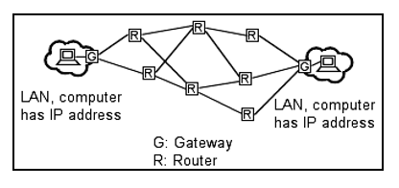
Figure 2.1 Routers and Gateways
Referred to Figure 2.1, it shows the connections between two computers by gateway and routers. A gateway is widget that translates data from one protocol (like TCP/IP) to another protocol (like AppleTalk) as it flies past. The widget may also choose to not translate some packets, and filter them out. The most important characteristic of a gateway is protocol translation
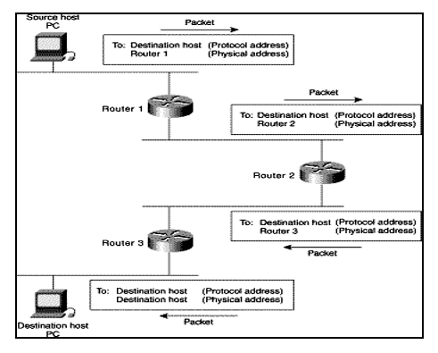.
Figure 2.2 Example for Numerous Routers
Referred to Figure 2.2, it should have known that routing involves two basic activities:
• Determining optimal routing paths
• Transporting information groups (typically called packets) through an Inter-network.
In the context of the routing process, the latter of these is referred to as packet switching. Although packet switching is relatively straightforward, path determination can be very complex. However, the Linux router is easy to handle and configure. It does not require any special care for its use other than that required for a normal PC. If there is any problem, configuring it only takes a few minutes
The OSI model above is the basic model describing the data movement through a network. The Open Systems Interconnection (OSI) reference model describes how information from a software application in one computer moves through a network medium to a software application in another computer.
The model is a conceptual model composed of seven layers, each specifying particular network functions. It divides the tasks involved with moving information between networked computers into seven smaller, more manageable task groups, then assigned to each of the seven OSI layers.
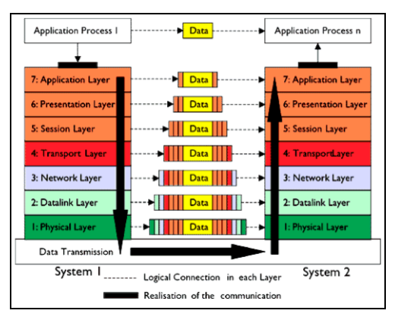
Figure 2.3 OSI Reference Model

We can refer to Figure 2.3; the primary difference between the two is that bridging occurs at Layer 2 (the link layer) of the OSI reference model, whereas routing occurs at Layer 3 (the network layer). This distinction provides routing and bridging with different information to use in the process of moving information from source to destination, so the two functions accomplish their tasks in different ways.

When we send any data across the network, it flows in the form of packet, besides containing data itself these packets contains two addresses. One which is assigned to the machine sending data i.e. source address and other assigned to the machine receiving data i.e. destination address. The addresses, which we are talking about, are known as IP addresses. IP stands for internet protocol. All computers across the internet are assigned a globally unique identifier called IP address. IP addresses are used as street addresses so other computers can locate them, these addresses takes the form of four numbers separated by dots e.g. 124.45.69.89.
2.2 TCP / IP
TCP/IP is the suite of protocols used by the Internet and most LANs throughout the world. In TCP/IP, every host (computer or other communications device) that is connected to the network has a unique IP address. An IP address is composed of four octets (numbers in the range of 0 to 255) separated by decimal points. The IP address is used to uniquely identify a host or computer on the LAN. For example, a computer with the hostname Hostlinux could have an IP address of 192.168.7.127. We should avoid giving two or more computers the same IP address by using the range of IP addresses that are reserved for private, local area networks; this range of IP addresses usually begins with the octets 192.168
2.3 Local Area Network (LAN)
2.3.1 LAN network address
The first three octets of an IP address should be the same for all computers in the LAN. For example, if a total of 128 hosts exist in a single LAN, the IP addresses could be assigned starting with 192.168.1.x, where x represents a number in the range of 1 to 128.
We could create consecutive LANs within the same company in a similar manner consisting of up to another 128 computers. Of course, we are not limited to 128 computers because there are other ranges of IP addresses that allow us to build even larger networks. There are different classes of networks that determine the size and total possible unique IP addresses of any given LAN. For example, a class A LAN can have over 16 million unique IP addresses. A class B LAN can have over 65,000 unique IP addresses.
Address range | Subnet mask | Provides | Addresses per LAN
10.0.0.0- 10.255.255.255 | 255.0.0.0 | 1 class A LAN | 16,777,216
172.16.0.0 - 172.31.255.255 | 255.255.0.0 | 16 class B LANs | 65,536
192.168.0.0 - 192.168.255.255 | 25.255.255.0 | 256 class C LANs | 256
Table 2.3.1 Address ranges and LAN sizes
According to Table 2.1, it shows that the size of our LAN depends on which reserved address range we use and the subnet mask associated with that range.
2.3.2 Network and broadcast addresses
Another important aspect of building a LAN is that the addresses at the two extreme ends of the address range are reserved for use as the LAN’s network address and broadcast address. The network address is used by an application to represent the overall network. The broadcast address is used by an application to send the same message to all other hosts in the network simultaneously.
For example, if we use addresses in the range of 192.168.1.0 to 192.168.1.128, the first address (192.168.1.0) is reserved as the network address, and the last address (192.168.1.128) is reserved as the broadcast address.
Therefore, we only assign individual computers on the LAN IP addresses in the range of 192.168.1.1 to 192.168.1.127:
Network address: | 192.168.1.0
Individual hosts: | 192.168.1.1 to 192.168.1.127
Broadcast address: | 192.168.1.128
Table 2.3.2 LAN IP addresses
2.3.3 Subnet masks
Each host in a LAN has a subnet mask. The subnet mask is an octet that uses the number 255 to represent the network address portion of the IP address and a zero to identify the host portion of the address. For example, the subnet mask 255.255.255.0 is used by each host to determine which LAN or class it belongs to. The zero at the end of the subnet mask represents a unique host within that network.
2.3.4 Domain name
The domain name, or network name, is a unique name followed by a standard Internet suffixes such as .com, .org, .mil, .net, etc. We can pretty much name our LAN anything if it has a simple dial-up connection and our LAN is not a server providing some type of service to other hosts directly.
In addition, our sample network is considered private since it uses IP addresses in the range of 192.168.1.x. Most importantly, the domain name of choice should not be accessible from the Internet if the above constraints are strictly enforced. Then, to obtain an "official" domain name we could register through InterNIC, Network Solutions or Register.com.
2.3.5 Hostnames
Another important step in setting up a LAN is assigning a unique hostname to each computer in the LAN. A hostname is simply a unique name that can be made up and is used to identify a unique computer in the LAN. In addition, the name should not contain any blank spaces or punctuation.
For example, the following are valid hostnames that could be assigned to each computer in a LAN consisting of 5 hosts: hostname 1 - Try; hostname 2 - Truck; hostname 3 - Tank; hostname 4 - Time; and hostname 5 - Tide. Each of these hostnames conforms to the requirement that no blank spaces or punctuation marks are present. Use short hostnames to eliminate excessive typing, and choose a name that is easy to remember.
Table 2.3 summarizes what we have covered. Every host in the LAN will have the same network address, broadcast address, subnet mask, and domain name because those addresses identify the network in its entirety. Each computer in the LAN will have a hostname and IP address that uniquely identifies that particular host. The network address is 192.168.1.0, and the broadcast address is 192.168.1.128. Therefore, each host in the LAN must have an IP address between 192.168.1.1 to 192.168.127.
IP address | Example | Same/unique
Network address | 192.168.1.0 | Same for all hosts
Domain name | www.yourcompanyname.com | Same for all hosts
Broadcast address | 192.168.1.128 | Same for all hosts
Subnet mask | 255.255.255.0 | Same for all hosts
Hostname | Any valid name | Unique to each host
Host addresses | 192.168.1.x | x must be unique to each host
Table 2.3.5 Sample IP addresses for LAN

2.4 Literature Review on Network Monitoring

2.4.1 S-LP Monitoring

Numerous studies have focused on the topic of S-LP deployment so as to achieve UFL under various scenarios. A greedy algorithm for the purpose, which is characterized by Random Code Assignment (RCA) and Random Code Swapping (RCS), was proposed in to solve the single link UFL problem; while the same problem was previously formulated into an ILP and solved in small topologies. An important technique developed in is that link code is firstly randomly assigned, followed by RCS which tries to improve the quality of the final solution by randomly swapping the alarm codes for a pair of links.

The study of improved the algorithm in by sequentially generating valid m-trails in a deterministic manner to shorten the running time. In particular, the scheme in generates an m-trail by interconnecting some fragments using shortest paths, which are in turn constructed by picking some weighted links. The longest fragment will be chosen as the new m-trail if the fragments are still disconnected.

The authors of firstly applied combinatorial group testing (CGT) techniques to non-adaptive UFL for SRLGs with up to d links, targeting at minimizing the number of parallel probes. To achieve this goal, a fault-free subgraph is identified in the network through a group of parallel probes and served as a hub to route other necessary probes to pinpoint failure. The upper and/or lower bounds on the number of non-adaptive probes needed for different classes of topologies are also discussed.

In failure identification for SRLGs with up to d links is studied based on greedy code swapping and d-separable CGT code assignment. In the SRLGs with adjacent links are considered.

The proposed heuristic, which partitions the network to remove the dependency of codes assigned to each link, performs good in terms of monitoring locations and computation efficiency. Since the set of S-LPs in a UFL solution may terminate at different nodes, the scheme in imposes a significant overhead in collecting the alarms for the UFL decision.
To avoid such overhead, the study in allows each on-trail node to tap the optical supervisory signal and thus share the status information of the m-trail. Both ILPs (Integer Linear Program) and heuristics were developed, which demonstrated effectiveness of the framework in suppressing the consumed monitoring resources.
The lower bounds of the required number of monitoring paths for single link UFL are analyzed in. Based on the derived bounds, the proposed bisection method produces a set of monitoring paths terminated at a set of predefined nodes to achieve UFL. In both monitoring paths and monitoring cycles are deployed to identify any SRLG failure by using a heuristic and an ILP. The feasibility conditions on the network connectivity as well as the placement of monitoring locations are addressed. To save the hardware cost of monitors, used a super monitor which is placed at the junction of a set of m-cycles.
The supervisory signals from the laser inside each super monitor are split simultaneously onto multiple m-cycles using an optical splitter. Since a small number of super monitors is desired, the problem of determining the optimal number and locations of super monitors was formulated as an add-on feature of any existing cyclebased scheme. Candidate cycle sets are enumerated first and the placement of the super monitors are decided by an ILP.
As an endeavor to suppress the supervisory wavelength-links (WLs) consumption and the cost of transmitters, the monitoring-tree (m-tree) approach is introduced. In the m-tree approach, a single laser diode is placed at a node to transmit uni-directional supervisory signal over a single link. When hitting a node, the signal can be terminated, forwarded through a single outgoing link, or duplicated and sent to multiple outgoing links. The m-tree approach is advantageous in that it usually requires one laser diode and keeps the number of wavelength-links to minimum. However, the number of monitors consumed is at least half of the number of links even for single link UFL.

2.4.2 W-LP Monitoring

Other studies only utilizes the W-LPs to pinpoint the failure source in a best effort manner. In an end-to-end fault detection and localization protocol is proposed. The source node of each W-LP keeps sending hello packets to the destination node along the lightpath. The alarm for an W-LP is triggered once a certain number of consecutive hello packets are missed within a given time. Then all alarms are reported to the centralized network management system (NMS) to locate the network fault. As such a protocol has no prior knowledge on the network topology and only relies on the alarms collected simultaneously from W-LPs to locate the failure source, this protocol cannot guarantee UFL.
In a probabilistic failure localization method is proposed based on establishing normalized fault vectors and construction of components matrix according to current allocation of monitors. Each fault vector corresponds to a network part to identify and a situation vector is defined to report the current status of all monitors.
In consideration of the frequencies of all alarms, a weighted component matrix is constructed based on fault vectors. Similar to the alarms are reported to a centralized managerial centre of the network and this method can not guarantee UFL. Unlike the probabilistic method outputs a prioritized list of possible failure candidates by computing the cross-product of the situation vector and the weighted component matrix. Moreover, this method can also handle false or lost alarms to some extent.
In the authors investigated the failure localization problem by minimizing the active monitors along the W-LPs for centralized and hierarchically-distributed management. Just like the technique proposed in their paper can only provide failure localization in a best effort way as the W-LPs and the monitor allocation can not guarantee UFL of the network parts under consideration. They proved the NP-completeness of the optimal monitor activation problem and presented its Integer Linear Programming (ILP) formulation as well as a greedy heuristic.
The alarms are collected either centrally or hierarchically depending on the adopted management scheme. The authors in exercised the idea of monitoring with W-LPs at the cost of additional optical-splitters when there are no dedicated bandwidth for monitoring.
The main observation in the paper is that the inclusion of an optical splitter is equivalent to adding a new lightpath to the monitoring system. They formulate the problem as an ILP which aims to find the minimum number of splitters and their placement such that the failure of an SRLG can be uniquely localized. Note that this is also an best-effort approach as UFL is feasible only when the W-LPs meet certain criteria. In the context of IP over optical networks, researchers formulated an ILP in to solve the single (physical) link failure localization problem through selecting a set of precomputed W-LPs, each of which maps to a logical link in the upper (IP) layer.
The objective of their ILP is to minimize: the number of unidentifiable physical links (primary); the number of physical links with identical alarm code (secondary) and the number of physical links used by W-LPs (tertiary).
Numeric results show their ILP can achieve best-effort failure localization. The authors adopt risk modeling to translate high-level failure notifications (e.g. alarms from W-LPs) to low-level causes (e.g. failure of an SRLG in the optical layer). Two inputs are fed into the proposed localization engine: risk model and failure signature. In a risk model, a physical object (e.g. a fiber) usually represents a shared risk for a group of logical entities at an upper layer (e.g. IP layer).
A failure signature is defined to be aset of monitoring observations (e.g. alarms of W-LPs). Note that these observations may contain “false alarms” like and their best-effort greedy heuristic can effectively reduce the number of the suspicious fault causes and the number of “false causes” returned by the algorithm.
2.4.3 Joint Monitoring of S-LPs and W-LPs
Some recent studies started to allocate S-LPs in consideration of the W-LPs. The authors suggested to manipulate the alarm code table (ACT) to come up with a feasible trial solution for single link failure localization, where “do not care” terms are introduced and manipulated. In their approach, the W-LPs are filled into the ACT so that the S-LPs can be deployed later to achieve UFL. Path labels, which are composed of link labels, are inserted into the W-LPs to passively monitor the network link failure status. When some labels are found missing by the monitors on the W-LPs, active probes are launched sequentially to detect more link states if the passive monitoring result cannot fully identify the failure source.
Note that an active probe is a light path constructed adaptively according to the result of the previous probe. This approach is advantageous in requiring almost no dedicated bandwidth and less monitors; however, it only deals with single link failure and more time is consumed compared to the non-adaptive m-trail method.
The authors assume that all Optical Cross Connects(OXC) can detect in band Loss of Light(LOL) and the faults propagate and raise alarms downstream from the point of failure along all affected light paths. Both ILP and a heuristic are given to solve the problem. However, the heuristic just pick S-LPs from the pre-computed k-shortest paths which can consume a lot of monitoring resources.
It is considered of ultimate importance to come up with an effective approach to jointly consider W-LPs and S-LPs such that the consumed resources are the minimal. As far as we know, no systematic approach has been available to exactly quantify how each newly added S-LP contributes to the identification of a set of SRLGs before we proposed the heuristic in.

CHAPTER 3

SOFTWARE REQUIREMENT SPECIFICATION
3.1 RAM
Alternatively referred to as main memory, primary memory, or system memory, Random Access Memory (RAM) is a hardware device that allows information to be stored and retrieved on a computer. RAM is usually associated with DRAM, which is a type of memory module. Because information is accessed randomly instead of sequentially like it is on a CD or hard drive, the computer can access the data much faster. However, unlike ROM or the hard drive, RAM is a volatile memory and requires power to keep the data accessible. If the computer is turned off, all data contained in RAM is lost.

Tip: New users often confuse RAM with disk drive space. See our memory definition for a comparison between memory and storage.

3.1.1 Types of RAM

Over the evolution of the computer there have been different variations of RAM. Some of the more common examples are DIMM, RIMM, SIMM, SO-DIMM, and SOO-RIMM. Below is an example image of a 512 MB DIMM computer memory module, a typical piece of RAM found in desktop computers. This memory module would be installed into one of the memory slots on a motherboard.

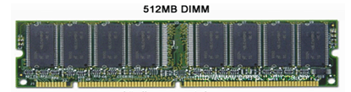

Figure 3.1 Random Access Memory (RAM)

Additional information

As the computer boots, parts of the operating system and drivers are loaded into memory, which allows the CPU to process the instructions faster and speeds up the boot process. After the operating system has loaded, each program you open, such as the browser you're using to view this page, is loaded into memory while it is running. If too many programs are open the computer will swap the data in the memory between the RAM and the hard disk drive.

History of RAM

The first form of RAM came about in 1947 with the use of the Williams tube. It utilized a cathode ray tube (CRT) and data was stored on the face of the CRT as electrically charged spots.
The second widely used form of RAM was magnetic-core memory, invented in 1947. Frederick Viehe is credited with much of the work, having filed for several patents relating to the design. Magnetic-core memory works through the use of tiny metal rings and wires connecting to each ring. One bit of data could be stored per ring and accessed at any time.

However, RAM as we know it today, as solid state memory, was first invented in 1968 by Robert Dennard. Known specifically as dynamic random access memory, or DRAM, transistors were used to store bits of data.

3.2 Router
A router is a networking device that forwards data packets between computer networks. Routers perform the traffic directing functions on the Internet. A data packet is typically forwarded from one router to another router through the networks that constitute the internetwork until it reaches its destination node.
A router is connected to two or more data lines from different networks. When a data packet comes in on one of the lines, the router reads the address information in the packet to determine the ultimate destination. Then, using information in its routing table or routing policy, it directs the packet to the next network on its journey. This creates an overlay internetwork.
The most familiar type of routers are home and small office routers that simply pass IP packets between the home computers and the Internet. An example of a router would be the owner's cable or DSL router, which connects to the Internet through an Internet service provider (ISP). More sophisticated routers, such as enterprise routers, connect large business or ISP networks up to the powerful core routers that forward data at high speed along the optical fiber lines of the Internet backbone. Though routers are typically dedicated hardware devices, software-based routers also exist.

3.3 Graphical User Interface

The graphical user interface, is a type of user interface that allows users to interact with electronic devices through graphical icons and visual indicators such as secondary notation, instead of text-based user interfaces, typed command labels or text navigation. GUIs were introduced in reaction to the perceived steep learning curve of command-line interfaces (CLIs), which require commands to be typed on a computer keyboard.

The actions in a GUI are usually performed through direct manipulation of the graphical elements. Beyond computers, GUIs are used in many handheld mobile devices such as MP3 players, portable media players, gaming devices, smartphones and smaller household, office and industrial controls. The term GUI tends not to be applied to other lower-display resolution types of interfaces, such as video games (where heads-up display (HUD) is preferred), or not including flat screens, like volumetric displays because the term is restricted to the scope of two-dimensional display screens able to describe generic information, in the tradition of the computer science research at the Xerox Palo Alto Research Center (PARC)

.

3.4 Code Blocks

Code Blocks is a free, open-source cross-platform IDE that supports multiple compilers including GCC, Clang and Visual C++. It is developed in C++ using wxWidgets as the GUI toolkit. Using a plugin architecture, its capabilities and features are defined by the provided plugins. Currently, Code::Blocks is oriented towards C, C++, and Fortran. It has a custom build system and optional Make support.

Code::Blocks is being developed for Windows, Linux, and macOS and has been ported to FreeBSD. OpenBSD and Solaris.

3.4.1 Features

Compilers

Code::Blocks supports multiple compilers, including GCC, MinGW, Digital Mars, Microsoft Visual C++, Borland C++, LLVM Clang, Watcom, LCC and the Intel C++ compiler. Although the IDE was designed for the C++ language, there is some support for other languages, including Fortran and D. A plug-in system is included to support other programming languages.

Code editor

The IDE features syntax highlighting and code folding (through its Scintilla editor component), C++ code completion, class browser, a hex editor and many other utilities. Opened files are organized into tabs. The code editor supports font and font size selection and personalized syntax highlighting colours.

Debugger

The Code::Blocks debugger has full breakpoint support. It also allows the user to debug their program by having access to the local function symbol and argument display, user-defined watches, call stack, disassembly, custom memory dump, thread switching, CPU registers and GNU Debugger Interface.

GUI designer

As of version 13.12 Code::Blocks comes with a GUI designer called Smith. It is a derivative port of Widgets version 2.9.4. To make a complete Widgets application, the appropriate Widgets SDK must be installed.

User migration

Some of Code::Blocks features are targeted at users migrating from other IDE's - these include Dev-C++, Microsoft Visual C++ project import (MSVC 7 & 10), and Dev.-C++ Devpak support.

Project files and build system

Code::Blocks uses a custom build system, which stores its information in XML-based project files. It can optionally use external make files, which simplifies interfacing with projects using the GNU or qmake build systems.

3.5 Windows

Windows OS, computer operating system (OS) developed by Microsoft Corporation to run personal computers (PCs). Featuring the first graphical user interface (GUI) for IBM-compatible PCs, the Windows OS soon dominated the PC market. Approximately 90 percent of PCs run some version of Windows.

The first version of Windows, released in 1985, was simply a GUI offered as an extension of Microsoft’s existing disk operating system, or MS-DOS. Based in part on licensed concepts that Apple Inc. had used for its Macintosh System Software, Windows for the first time allowed DOS users to visually navigate a virtual desktop, opening graphical “windows” displaying the contents of electronic folders and files with the click of a mouse button, rather than typing commands and directory paths at a text prompt.

Subsequent versions introduced greater functionality, including native Windows File Manager, Program Manager, and Print Manager programs, and a more dynamic interface. Microsoft also developed specialized Windows packages, including the networkable Windows for Workgroups and the high-powered Windows NT, aimed at businesses. The 1995 consumer release Windows 95 fully integrated Windows and DOS and offered built-in Internet support, including the World Wide Web browser Internet Explorer.

With the 2001 release of Windows XP, Microsoft united its various Windows packages under a single banner, offering multiple editions for consumers, businesses, multimedia developers, and others. Windows XP abandoned the long-used Windows 95 kernel (core software code) for a more powerful code base and offered a more practical interface and improved application and memory management.

The highly successful XP standard was succeeded in late 2006 by Windows Vista, which experienced a troubled rollout and met with considerable marketplace resistance, quickly acquiring a reputation for being a large, slow, and resource-consuming system. Responding to Vista’s disappointing adoption rate, Microsoft in 2009 released Windows 7, an OS whose interface was similar to that of Vista but was met with enthusiasm for its noticeable speed improvement and its modest system requirements.

Windows 8 in 2012 offered a start screen with applications appearing as tiles on a grid and the ability to synchronize settings so users could log on to another Windows 8 machine and use their preferred settings. In 2015 Microsoft released Windows 10, which came with Cortana, a digital personal assistant like Apple’s Siri, and the Web browser Microsoft Edge, which replaced Internet Explorer. Microsoft also announced that Windows 10 would be the last version of Windows, meaning that users would receive regular updates to the OS but that no more large-scale revisions would be done.

3.6 Linux

Linux is a Unix-like computer operating system assembled under the model of free and open-source software development and distribution. The defining component of Linux is the Linux kernel, an operating system kernel first released on September 17, 1991 by Linus Torvalds. The Free Software Foundation uses the name GNU/Linux to describe the operating system, which has led to some controversy.

Linux was originally developed for personal computers based on the Intel x86 architecture, but has since been ported to more platforms than any other operating system. Because of the dominance of Android on smartphones, Linux has the largest installed base of all general-purpose operating systems. Linux is also the leading operating system on servers and other big iron systems such as mainframe computers, and is used on 99.6% of the TOP500 supercomputers. It is used by around 2.3% of desktop computers. The Chrome book, which runs the Linux kernel-based Chrome OS, dominates the US K–12 education market and represents nearly 20% of the sub-$300 notebook sales in the US. Linux also runs on embedded systems – devices whose operating system is typically built into the firmware and is highly tailored to the system. This includes TiVo and similar DVR devices, network routers, facility automation controls, televisions, video game consoles and smart watches. Many smartphones and tablet computers run Android and other Linux derivatives.

The development of Linux is one of the most prominent examples of free and open-source software collaboration. The underlying source code may be used, modified and distributed‍—‌commercially or non-commercially‍—‌by anyone under the terms of its respective licenses, such as the GNU General Public License. Typically, Linux is packaged in a form known as a Linux distribution (or distro for short) for both desktop and server use. Some of the most popular mainstream Linux distributions are Arch Linux, CentOS, Debian, Fedora, Gentoo Linux, Linux Mint, Mageia, openSUSE and Ubuntu, together with commercial distributions such as Red Hat Enterprise Linux and SUSE Linux Enterprise Server. Distributions include the Linux kernel, supporting utilities and libraries, many of which are provided by the GNU Project, and usually a large amount of application software to fulfil the distribution's intended use.

Desktop Linux distributions include a windowing system, such as X11, Mir or a Wayland implementation, and an accompanying desktop environment such as GNOME or the KDE Software Compilation; some distributions may also include a less resource-intensive desktop, such as LXDE or Xfce. Distributions intended to run on servers may omit all graphical environments from the standard install, and instead include other software to set up and operate a solution stack such as LAMP. Because Linux is freely redistributable, anyone may create a distribution for any intended use.

CHAPTER 4
PROBLEM ANALYSIS
The duration of the packet delivery disruption caused by a conventional routing transition is determined by a number of factors:

- The time taken to detect the failure. This may be of the order of a few milliseconds when it can be detected at the physical layer, up to several tens of seconds when a routing protocol Hello is employed. During this period, packets will be unavoidably lost.
- The time taken for the local router to react to the failure. This will typically involve generating and flooding new routing updates, perhaps after some hold-down delay, and re-computing the router's FIB.
- The time taken to pass the information about the failure to other routers in the network. In the absence of routing protocol packet loss, this is typically between 10 milliseconds and 100 milliseconds per hop.
- The time taken to re-compute the forwarding tables. This is typically a few milliseconds for a link state protocol using Dijkstra's algorithm.
- The time taken to load the revised forwarding tables into the forwarding hardware. This time is very implementation dependent and also depends on the number of prefixes affected by the failure, but may be several hundred milliseconds

The disruption will last until the routers adjacent to the failure have completed steps 1 and 2, and until all the routers in the network whose paths are affected by the failure have completed the remaining steps.

The initial packet loss is caused by the routers adjacent to the failure continuing to attempt to transmit packets across the failure until it is detected. This loss is unavoidable, but the detection time can be reduced to a few tens of milliseconds as described.

In some topologies, subsequent packet loss may be caused by the "micro-loops" which may form as a result of temporary inconsistencies between routers' forwarding tables. These inconsistencies are caused by steps 3, 4, and 5 above, and in many routers it is step 5 that is both the largest factor and that has the greatest variance between routers. The large variance arises from implementation differences and from the differing impact that a failure has on each individual router. For example, the number of prefixes affected by the failure may vary dramatically from one router to another.

In order to reduce packet disruption times to a duration commensurate with the failure detection times, two mechanisms may be required:

- A mechanism for the router adjacent to the failure to rapidly invoke a repair path, which is unaffected by any subsequent re- convergence.
- In topologies that are susceptible to micro-loops, a micro-loop control mechanism may be required.

Performing the first task without the second may result in the repair path being starved of traffic and hence being redundant. Performing the second without the first will result in traffic being discarded by the router(s) adjacent to the failure. Repair paths may always be used in isolation where the failure is short-lived. In this case, the repair paths can be kept in place until the failure is repaired, therefore there is no need to advertise the failure to other routers.

Similarly, micro-loop avoidance may be used in isolation to prevent loops arising from pre-planned management action. In which case the link or node being shut down can remain in service for a short time after its removal has been announced into the network, and hence it can function as its own "repair path".

Note that micro-loops may also occur when a link or node is restored to service, and thus a micro-loop avoidance mechanism may be required for both link up and link down cases.

CHAPTER 5
METHODOLOGY

Store back up look ahead table with back up nodes and links
During Failure at node or link refer routing table
Forwarding from Primary nodes and links.

Figure 5.1 Block Diagram
How network flooding works on regular network?
“Fast IP Rerouting” works under the principle of multi-path routing and flooding under node failure.
Current Scenarios
- Multicast routing.
- Unicast routing.
- Forward flooding

Flooding
In a network, flooding is the forwarding by a router of a packet from any node to every other node attached to the router except the node from which the packet arrived.
Flooding is a way to distribute routing information updates quickly to every node in a large network.
5.2 Scenario
The figure 5.2 represents 8-node network where links are represented by blue lines and path by green lines. Here an example of sending packets from 1 to 7 is considered. When the link 4 fails it routes packets from backup node to 7. Or if the next node itself is destination then it loops back the packets.

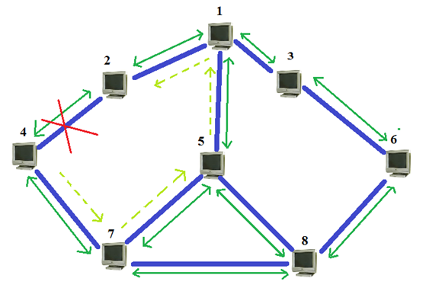

Figure 5.2 Networking Hub

5.3 Overview of project

Topology is always assumed to be survivable. That is removal of any link where failure occurs does not affect the spanning tree. The project involves the design and development of a system that works based on the information available in the neighboring nodes to reconstruct the routing information in form of table, algorithms used or data if available. The rerouting methodology uses IP addresses for the implementation. This project is an attempt to increase the response capabilities and reduce the time required to recover of a network in case of a node failure in general.

5.4 Overall Description

Enter 8 node LAN network
Display the network

Display the rerouting in the specified network with a deletion of particular node

Network graph with rerouting

SUBMIT
SUBMIT
CLEAR

Figure 5.4 Graphical User Interface
CHAPTER 6

MECHANISM

Mechanisms for IP Fast-Reroute

The set of mechanisms required for an effective solution to the problem can be broken down into the sub-problems described in this section.

6.1. Mechanisms for Fast Failure Detection

It is critical that the failure detection time is minimized. A number of well-documented approaches are possible, such as:

- Physical detection; for example, loss of light.
- Protocol detection that is routing protocol independent; for example, the Bidirectional Failure Detection protocol.
- Routing protocol detection; for example, use of "fast Hellos".

When configuring packet-based failure detection mechanisms it is important that consideration be given to the likelihood and consequences of false indications of failure. The incidence of false indication of failure may be minimized by appropriately prioritizing the transmission, reception, and processing of the packets used to detect link or node failure. Note that this is not an issue that is specific to IPFRR.

6.2. Mechanisms for Repair Paths

Once a failure has been detected by one of the above mechanisms, traffic that previously traversed the failure is transmitted over one or more repair paths. The design of the repair paths should be such that they can be pre-calculated in anticipation of each local failure and made available for invocation with minimal delay. There are three basic categories of repair paths:

- Equal cost multi-paths (ECMP). Where such paths exist, and one or more of the alternate paths do not traverse the failure, they may trivially be used as repair paths.
- Loop-free alternate paths. Such a path exists when a direct neighbour of the router adjacent to the failure has a path to the destination that can be guaranteed not to traverse the failure.
- Multi-hop repair paths. When there is no feasible loop-free alternate path it may still be possible to locate a router, which is more than one hop away from the router adjacent to the failure, from which traffic will be forwarded to the destination without traversing the failure.
ECMP and loop-free alternate paths (as described in offer the simplest repair paths and would normally be used when they are available. It is anticipated that around 80% of failures can be repaired using these basic methods alone.

Multi-hop repair paths are more complex, both in the computations required to determine their existence, and in the mechanisms required to invoke them. They can be further classified as:

- Mechanisms where one or more alternate FIBs are pre-computed in all routers, and the repaired packet is instructed to be forwarded using a "repair FIB" by some method of per-packet signalling such as detecting a "U-turn" or by marking the packet .
- Mechanisms functionally equivalent to a loose source route that is invoked using the normal FIB. These include tunnels, alternative shortest paths, and label-based mechanisms.
- Mechanisms employing special addresses or labels that are installed in the FIBs of all routers with routes pre-computed to avoid certain components of the network.
- In many cases, a repair path that reaches two hops away from the router detecting the failure will suffice, and it is anticipated that around 98% of failures can be repaired by this method. However, to provide complete repair coverage, some use of longer multi-hop repair paths is generally necessary.

6.2.1. Scope of Repair Paths
A particular repair path may be valid for all destinations which require repair or may only be valid for a subset of destinations. If a repair path is valid for a node immediately downstream of the failure, then it will be valid for all destinations previously reachable by traversing the failure. However, in cases where such a repair path is difficult to achieve because it requires a high order multi-hop repair path, it may still be possible to identify lower- order repair paths (possibly even loop-free alternate paths) that allow the majority of destinations to be repaired. When IPFRR is unable to provide complete repair, it is desirable that the extent of the repair coverage can be determined and reported via network management.

There is a trade-off between minimizing the number of repair paths to be computed, and minimizing the overheads incurred in using higher- order multi-hop repair paths for destinations for which they are not strictly necessary. However, the computational cost of determining repair paths on an individual destination basis can be very high.

It will frequently be the case that the majority of destinations may be repaired using only the "basic" repair mechanism, leaving a smaller subset of the destinations to be repaired using one of the more complex multi-hop methods. Such a hybrid approach may go some way to resolving the conflict between completeness and complexity.
The use of repair paths may result in excessive traffic passing over a link, resulting in congestion discard. This reduces the effectiveness of IPFRR. Mechanisms to influence the distribution of repaired traffic to minimize this effect are therefore desirable.

6.2.2. Analysis of Repair Coverage
The repair coverage obtained is dependent on the repair strategy and highly dependent on the detailed topology and metrics. Estimates of the repair coverage quoted in this document are for illustrative purposes only and may not be always be achievable.

In some cases the repair strategy will permit the repair of all single link or node failures in the network for all possible destinations. This can be defined as 100% coverage. However, where the coverage is less than 100%, it is important for the purposes of comparisons between different proposed repair strategies to define what is meant by such a percentage. There are four possibilities:

- The percentage of links (or nodes) that can be fully protected (i.e., for all destinations). This is appropriate where the requirement is to protect all traffic, but some percentage of the possible failures may be identified as being un-protectable.

- The percentage of destinations that can be protected for all link (or node) failures. This is appropriate where the requirement is to protect against all possible failures, but some percentage of destinations may be identified as being un-protectable.

- For all destinations (d) and for all failures (f), the percentage of the total potential failure cases (d*f) that are protected. This is appropriate where the requirement is an overall "best- effort" protection.

- The percentage of packets normally passing though the network that will continue to reach their destination. This requires a traffic matrix for the network as part of the analysis.

6.2.3. Link or Node Repair
A repair path may be computed to protect against failure of an adjacent link, or failure of an adjacent node. In general, link protection is simpler to achieve. A repair which protects against node failure will also protect against link failure for all destinations except those for which the adjacent node is a single point of failure.

In some cases, it may be necessary to distinguish between a link or node failure in order that the optimal repair strategy is invoked. Methods for link/node failure determination may be based on techniques such as BFD. This determination may be made prior to invoking any repairs, but this will increase the period of packet loss following a failure unless the determination can be performed as part of the failure detection mechanism itself. Alternatively, a subsequent determination can be used to optimize an already invoked default strategy.

6.2.4. Maintenance of Repair Paths

In order to meet the response-time goals, it is expected (though not required) that repair paths, and their associated FIB entries, will be pre-computed and installed ready for invocation when a failure is detected. Following invocation, the repair paths remain in effect until they are no longer required. This will normally be when the routing protocol has re-converged on the new topology taking into account the failure, and traffic will no longer be using the repair paths.

The repair paths have the property that they are unaffected by any topology changes resulting from the failure that caused their instantiation. Therefore, there is no need to re-compute them during the convergence period. They may be affected by an unrelated simultaneous topology change, but such events are out of scope of this work.

Once the routing protocol has re-converged, it is necessary for all repair paths to take account of the new topology. Various optimizations may permit the efficient identification of repair paths that are unaffected by the change, and hence do not require full re-computation.
Since the new repair paths will not be required until the next failure occurs, the re-computation may be performed as a background task and be subject to a hold-down, but excessive delay in completing this operation will increase the risk of a new failure occurring before the repair paths are in place.
CHAPTER 7
DESIGN
Following table shows the graphical user Interface which represents the Simulation of FIRE with 8 nodes. The number of packets for each node is entered, and then the corresponding links between each node should be given.
Fast IP Re Routing Engine

Enter the Packets |  | Enter the Link for the Packet
To which Node you want to insert these values
N1 N2 N4 N5 N6 N7 N8 CLEAR
Node to be Deleted |  | Delete
GRAPH
Creation of 8 tables in DB and filling into it so that we can access each table easily using grid view and an form the graph easily
Figure 7.1 GUI of FIRE
7.1 Illustration
Considered for example 8 nodes with following number of packets and link for each node respectively. If first node contains 2 in the second column which represents links a line is drawn from node 1 to 2 in place of the link. OUT represents out- going packets .Similarly for all numbers in each node links are established and redundancies in link are avoided. Any mistakes while entering input can be canceled through clear button. Then following is resultant graph for the given input is as shown.
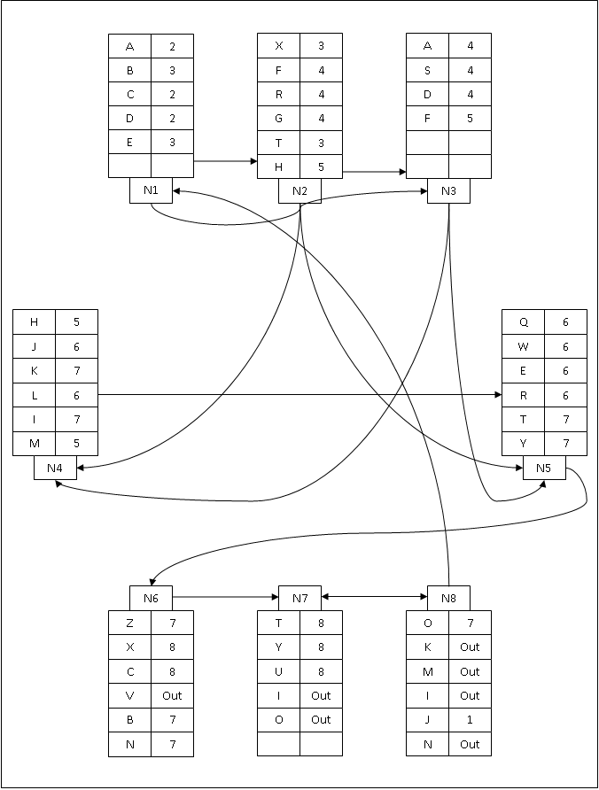
Figure 7.2 Resultant Graph of 8 nodes
7.2 Re- Routing
To Emphasize the purpose of FIRE’s Re Routing let’s consider a node to be deleted. Instead of erratically deleting any node significance for choice is given. After node is deleted updated graph is displayed. Updating consist of updating link in predominantly. If for Example node 6 is deleted then conspicuously only node 1 to 5 consists of link 6 so only node 1 to 5 should be updated with replacement of links of 6 to further links which are connected to node 6. The overall purpose of pupation is even after any node in network is failed routing should not be disturbed. The graph after node can be displayed by graph button. Graph with above example if node 5 is deleted then node 2, 3 and 4 with links are replaced by 6 or 7 but as 6 has more packets and hence traffic or load is more node 7 is chosen for substitution. Graph after node 5 is deleted following is the graph obtained as the outcome.
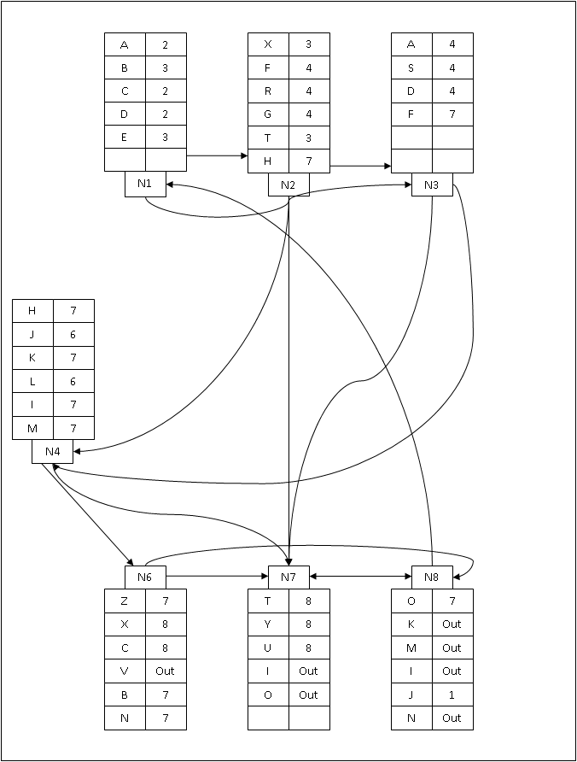
Figure 7.3 Resultant Graph of Rerouting
CHAPTER 8
IMPLEMENTATION
When new packets arrive get primary and back up nodes according to IP Address

Y
Arrive from primary node?

Primary port fails?
N

Y
Y
N

Use back up node
Use primary node

Figure 8.1 Flowchart of Routing Optimization

8.2 Single link failure recovery
When a failure occurs, a subset of the nodes switch to their backup ports for fast rerouting, and the set of forwarding paths are changed accordingly. The rerouting is correct if and only if the new set of forwarding paths still form a spanning tree with node 1 as the root.
8.3 Single node recovery
Single-node failures are different from single-link failures in that the failure of a node disables all the links directly connected to it. Consequently, several sub-trees could be detached from the primary tree.
To calculate back-up path we use IPL and in network designing link-state routing protocol like OSPF is used. The ILP provides a generic description of the problem, and has good flexibility in that it can be modified to achieve different optimization objectives with various constraints. Solving the ILP yields two set of variables, the backup nodes of each node and Configurations of the node selection when link fails.
The routing tables have two additional fields with backup node information to enable explicit rerouting in trailer as in the following format:
Prefix | Next node | Port | Backup node | Backup path
Table 8.3 Routing Table with Backup Node Information

CHAPTER 9
SOFTWARE TESTING
Software Testing is a process of investigation conducted for the purpose to provide stakeholders with information about quality of the software or hardware product and even service under test. Even testing can provide an independent, objective view of the product to allow the business to understand and risk involved in the implementation of software development. There is no limit for the process of executing a program or application from the intent of finding defects in the software or hardware product.

Another definition can be given as, it is the process of validating and verifying product has met necessary criteria.

- To check requirements are meet that guided its development and design.
- To check whether work is according to expectation.
- To check whether it has implemented with a unique characteristics.
- To check whether it has satisfied stakeholders need.

Testing mainly dependent on the methodology is adopted, and which can be implemented at any given time through the process of development. In certain cases, effort of testing occurs normally after when requirements are defined and development process has been finished. Agile process is adopted to test the product, to know effort simultaneously.

9.1 Testing Environment

There are number of software development models, which will focus differently on test from the point in process of development. Agile model will belongs to such new model, which implements a test driven from the perspective of development and place a rapid increase portion from the testing point of view before it moves to a formal team for testing.

The traditional model in testing occurs, after the necessary requirement has been defined and development process has been finished. The main goal of any testing process is to find errors/defects by adopting testing for individual program components. The components may be referred to as an object, module or function.

Verification
It is the process used to make sure that the product has satisfied the required conditions specified when the development phase started. In simple it can defined as, to make sure the system behavioral is same the way user expects.

Validation
It is the process used to make sure that the product has satisfied the required condition specified at the end of a development phase. In simple it can defined as, to make sure the software is built according to user requirement.

Error Detection
It is the process that every testing process should attempt to make thing go wrong, to determine if something occurs when it is required and something occurs when it is not required.

Testing goals are as follows:

- To know clear difference among defect testing and validation tests.
- To know objective of component testing and system tests.
- To know statistics for generating test cases.
- To know the unique characteristics of tools used for automation.

The process of testing can be grouped from the perspective they are added in the development of software product, or by indicating the level of testing. The important level during any process of development is as: system testing, unit testing, and integration testing.

9.2 Unit Testing
There exist a number of components in every sub-system. Every component is tested using respective test procedures. Each component is tested individually or with other components based on their needs.
Unit test focuses verification effort on the smallest unit of software design component or module.

9.3 Integration Testing
Integration tests are designed to test integrated software components to determine if they actually run as one program.

9.4 System Testing
Testing performs a very critical role for quality assurance and for ensuring reliability of the software. During testing, the program should be tested with a set of test cases and the output of the program for the test cases is evaluated to determine if the program is performing as expected. Testing forms the first step in determining the errors in a program. The success of testing in revealing errors in program depends critically on the test cases.

Testing a large system is a complex activity and hence it has to be broken into smaller activities, due to this incremental testing is generally performed for project in which components and sub-systems of a system are tested separately before integrating them to form the system for system testing. Integration of various components of the system is an important issue that the testing phase has to deal with.

Test data are inputs which have been devised to test the system whereas test cases are inputs to test the system and the outputs are predicted from these inputs if the system operates according to its specification. This is to examine the behavior in a cohesive system. The test cases are selected to ensure that the system behavior can be examined in all possible combinations of conditions.

Accordingly, expected behavior of the system under different combinations is given. Therefore test cases are selected which have inputs and the outputs are on expected lines, inputs that are not valid and for which suitable messages must be given and inputs that do not occur very frequently which can be regarded as special cases. In this chapter, several test cases have been explained.
CHAPTER 10
APPLICATIONS
10.1 Application of the project
- For all Internet Applications (e.g.: during online credit transactions and in security management network failure causes significant loss and hence there should be explicit/spontaneous recovery).
- In Business Applications where time plays critical role. It becomes extremely necessary and useful in guaranteed service networks. Also enhances the performance of best effort service networks.
CHAPTER 11
ADVANTAGES AND DISADVANTAGES

11.1 Disadvantages of the Existing System
- Load Distribution failed.
- Congestion occurring.
- There is no guarantee for data to reach the destination
- There is no back-up path
- It is time consuming
- It has no precise knowledge of failure locations

11.2 Advantages
- 100% message transfer is guaranteed.
- During message transfer the load is distributed which increases the speed of transmission.
- Overcome retransmission of large data.
- Reduces traffic on the same link.
- The failure of particular link is identified
- Our proposed System overcome all the disadvantages of Existing System.
- Multiple Routing Configurations (MRC) is a proactive and local protection mechanism that allows recovery in the range of milliseconds.
- MRC allows packet forwarding to continue over preconfigured alternative next-hops immediately after the detection of the failure.
CHAPTER 12
RESULTS AND SNAPSHOTS
CHAPTER 13
CONCLUSION AND FUTURE WORK
13.1 Conclusion

13.2 Future work
Fast rerouting with load balancing and shared link grouped into design. Similarly FIRE can be enhanced to perform under multiple link/node failures using agent based systems.
REFERENCES

- IEEE paper on IP Fast Re Routing for single link node failure recovery by Kang Xi and H Jonathan Chao.
- [RFC5286] Atlas, A. and A. Zinin, "Basic Specification for IP Fast Reroute: Loop-Free Alternates".
- [RFC5715] Shand, M. and S. Bryant, "A Framework for Loop-Free Convergence".

- D.Watson, F. Jahanian, and C. Labovitz, “Experiences with monitoring OSPF on a regional service provider network,” in Proc. 23rd Int. Conf. Distributed Computing Systems (ICDCS’03), Washington, DC, 2003, pp. 204–213, IEEE Computer Society.
- P. Francois, C. Filsfils, J. Evans, and O. Bonaventure, “Achieving sub-second IGP convergence in large IP networks,” ACM SIGCOMM Comput. Commun. Rev., vol. 35, no. 2, pp. 35–44, Jul. 2005.

APPENDIX

Definitions, Acronyms and Abbreviations
Fire | Fast IP Re Routing Engine
Spanning Tree | Tree consisting of all Vertices and Edges of the graph without any loop (cycle)
Survivable Topology | Spanning tree is unaffected with removal of any link or node
Routing | Process of selecting a path in a network along which data is transmitted.
Equal Cost Multipath Routing (ECMP) | Routing strategy where next-hop packet forwarding to a single destination can occur over multiple "best paths" which tie for top place in routing metric calculations
Open Shortest Path First (OSPF) | Adaptive routing protocol for Internet Protocol (IP) networks.
Integer Linear Programming ( ILP) | A linear program in real variables is said to be integral if it has at least one optimal solution which is integral
Bottle Neck | Phenomenon where the performance or capacity of an entire system is limited by a single or limited number of components or resources.

